**CHANDIGARH UNIVERSITY**

**UNIVERSITY INSTITUTE OF ENGINEERING**

**DEPARTMENT OF COMPUTER SCIENCE & ENGINEERING**



|  |  |
| --- | --- |
| **Submitted By:** Sahil Kaundal  **Submitted To:** Neeru Sharma | |
| **Subject Name** | Project Based Learning Java (Lab) |
| **Subject Code** | 20CSP-321 |
| **Branch** | Computer Science Engineering |
| **Semester** | 5th |

LAB INDEX

**NAME:** Sahil Kaundal **SUBJECT NAME:** PBLJ (Lab)

**UID:** 21BCS8197 **SUBJECT CODE:** 20CSP-321

**SECTION:** 20BCS_WM-616/A

|  |  |  |  |  |  |  |  |
| --- | --- | --- | --- | --- | --- | --- | --- |
| **Sr.No** | **Program** | **Date** | **Evaluation** | | | | **Sign** |
| **LW**  **(12)** | **VV**  **(10)** | **FW**  **(8)** | **Total**  **(30)** |
| 1. | Create an application to save the employee information using arrays. | 16/08/2022 |  |  |  |  |  |
| 2. | Design and implement a simple inventory control system for a small video rental store. | 20/08/2022 |  |  |  |  |  |
| 3. | Create a application to calculate interest for FDs, RDs based on certain conditions using inheritance. | 27/08/2022 |  |  |  |  |  |
| 4. | Create a program to set view of Keys from Java Hashtable. | 27/09/2022 |  |  |  |  |  |
| 5. | Create a program to show the usage of Sets of Collection interface. | 27/09/2022 |  |  |  |  |  |
| 6. | Write a Program to perform the basic operations like insert, delete, display and search in list. List contains String object items where these operations are to be performed. | 04/10/2022 |  |  |  |  |  |

**Experiment 6**

**Student Name:** Sahil Kaundal **UID:** 21BCS8197

**Branch:** BE CSE (Lateral Entry) **Section/Group:** 616/A

**Semester:** 5th **Date of Performance:** 04/10/2022

**Subject Name:** PBLJ Lab **Subject Code:** 20CSP-321

1. **Aim/Overview of the practical:**

Write a Program to perform the basic operations like insert, delete, display and search in list. List contains String object items where these operations are to be performed.

1. **Task to be done/ Which logistics used:**

Write the program to create an application to perform a List manipulation.

1. **Apparatus / Simulator Used:**

* Eclipse IDE - (Java)
* NetBeans.
* JDK-8 or any.

1. **Programs/ Code:**

package unit2;

import java.util.*;

import java.util.Scanner;

public class Exp6 {

public static List<String> list=new ArrayList<String>();

void addItem(String item) {

list.add(item);

}

void displayItem() {

if(list.size()>0) {

for(String name:list)

System.out.println(name);

}else

System.out.println("List is Empty");

}

void searchItem(String item) {

if(list.size()>0) {

if(list.contains(item))

System.out.println(item+" is Present");

else

System.out.println(item+" is not Present");

}else

System.out.println("List is Empty");

}

void deleteItem(String item) {

if(list.size()>0) {

if(list.contains(item)) {

list.remove(item);

System.out.println(item+" is removed");

}else

System.out.println(item+" is not Present");

}else

System.out.println("List is Empty");

}

public static void main(String[] args) {

Exp6 obj = new Exp6();

boolean flag=true;

String item;

int choice;

Scanner in = new Scanner(System.in);

while(flag) {

System.out.println("\nMAIN MENU");

System.out.println("*************");

System.out.println("1.Insert:");

System.out.println("2.Search:");

System.out.println("3.Delete:");

System.out.println("4.Display:");

System.out.println("5.Exit");

System.out.println("\nEnter your choice:");

choice = in.nextInt();

switch(choice)

{

case 1:

{

System.out.println("Enter the item: ");

item = in.next();

obj.addItem(item);

break;

}

case 2:

{

System.out.println("Enter the item: ");

item = in.next();

obj.searchItem(item);

break;

}

case 3:

{

System.out.println("Enter the item: ");

item = in.next();

obj.deleteItem(item);

break;

}

case 4:

{

System.out.println("\nElement of Lists are: ");

obj.displayItem();

break;

}

case 5:

{

System.out.println("Exiting...!! Thanks for using the application");

flag=false;

break;

}

default:

{

System.out.println("Wrong input!!");

}

}

}

in.close();

}

}

**5. Result/Output/Writing Summary:**

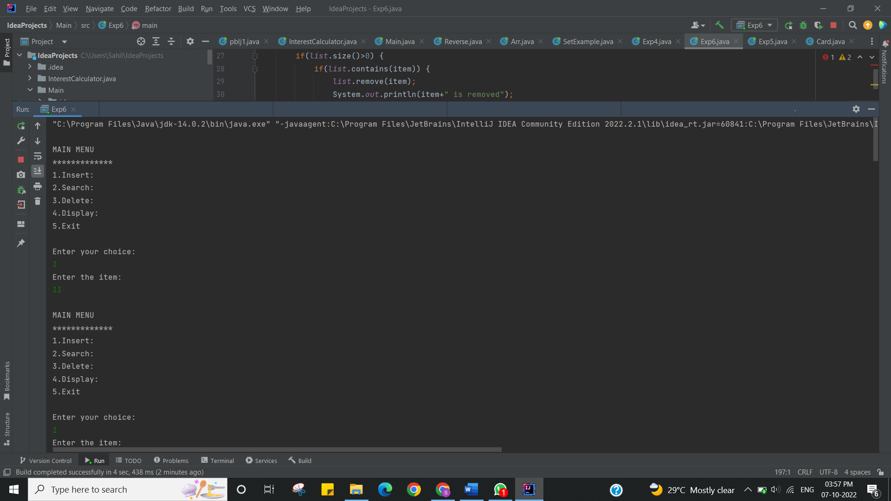

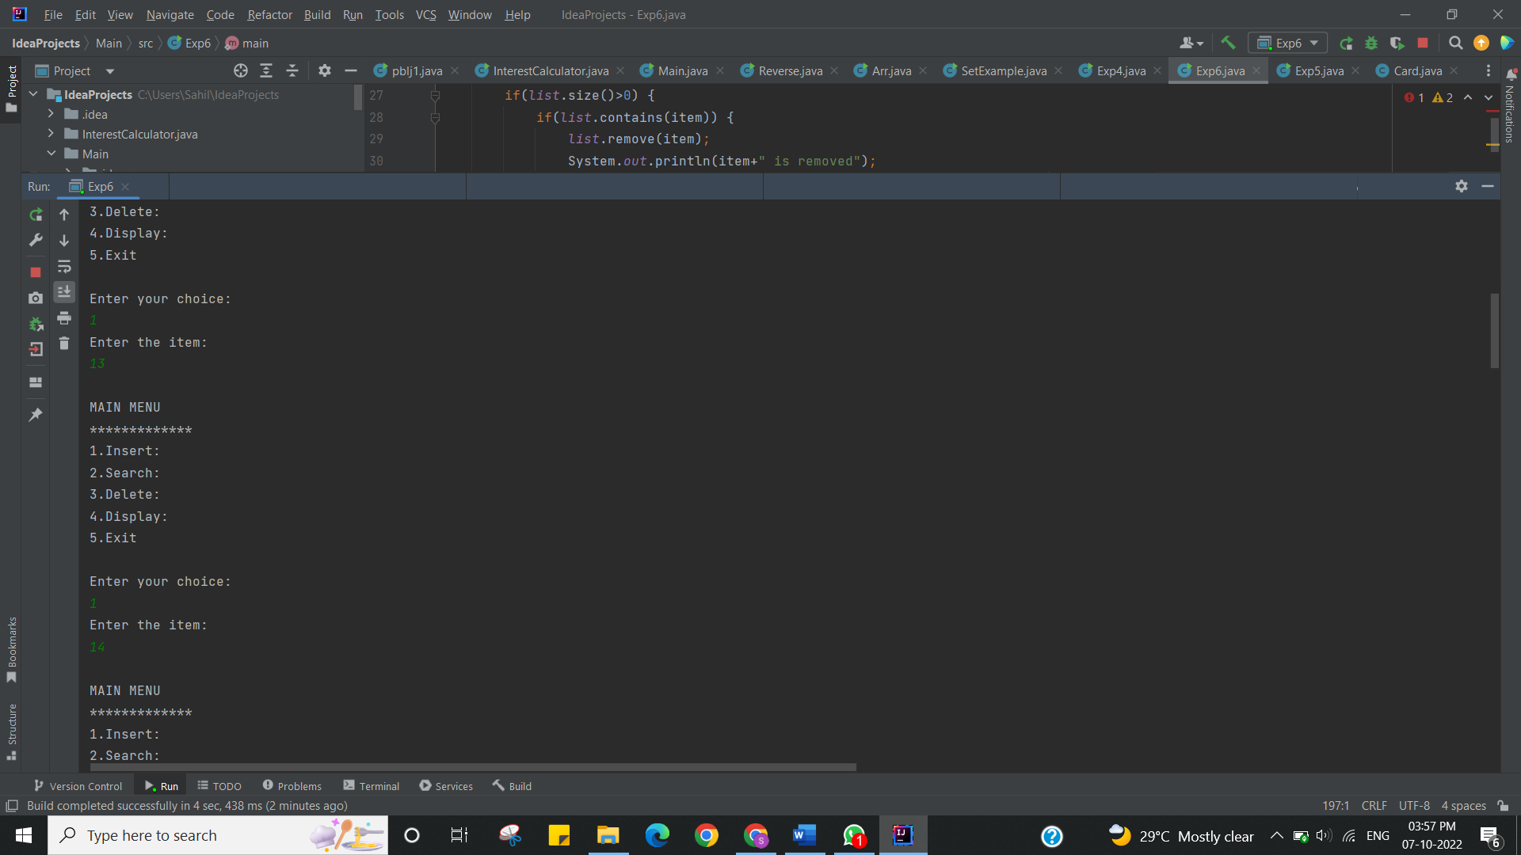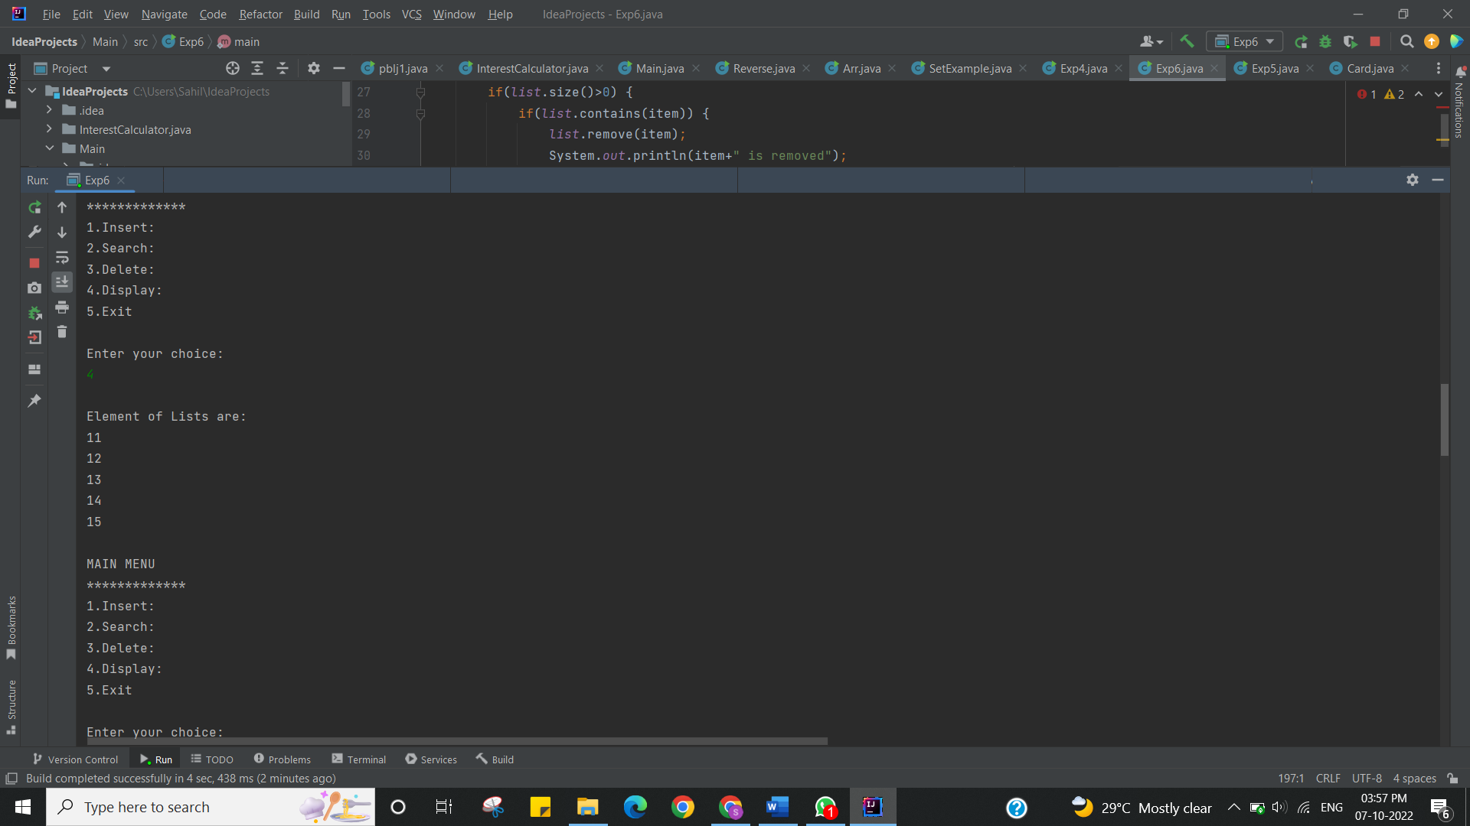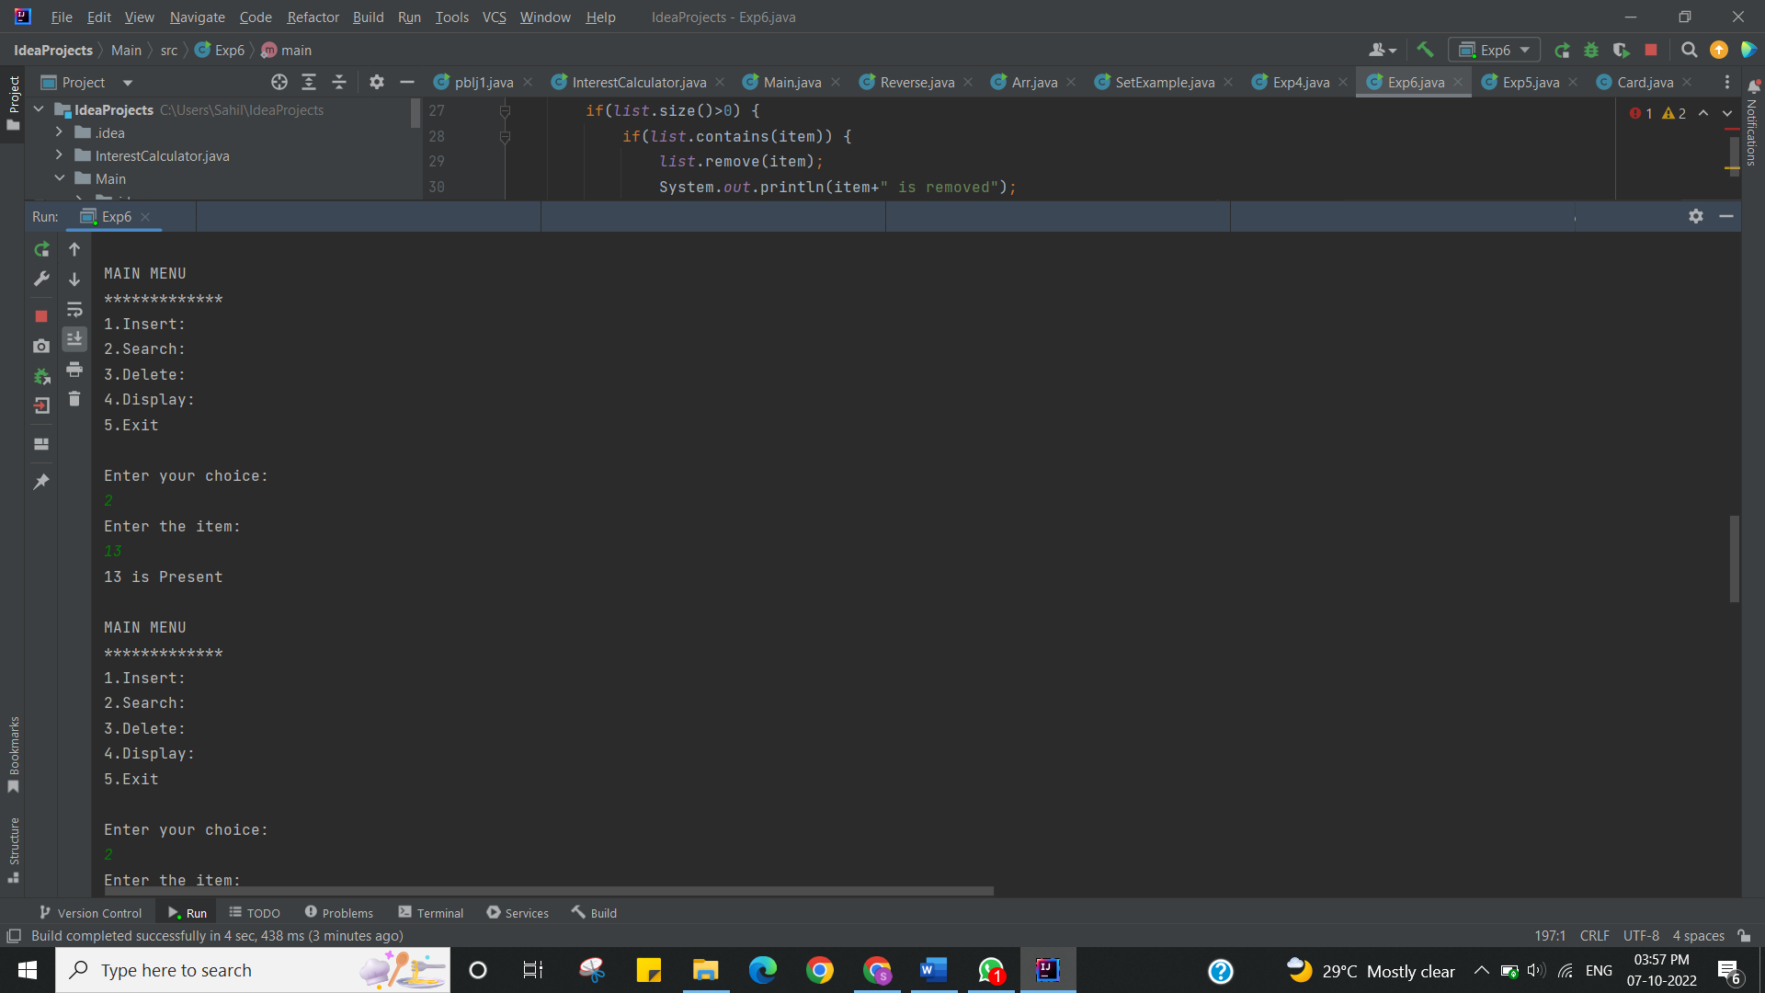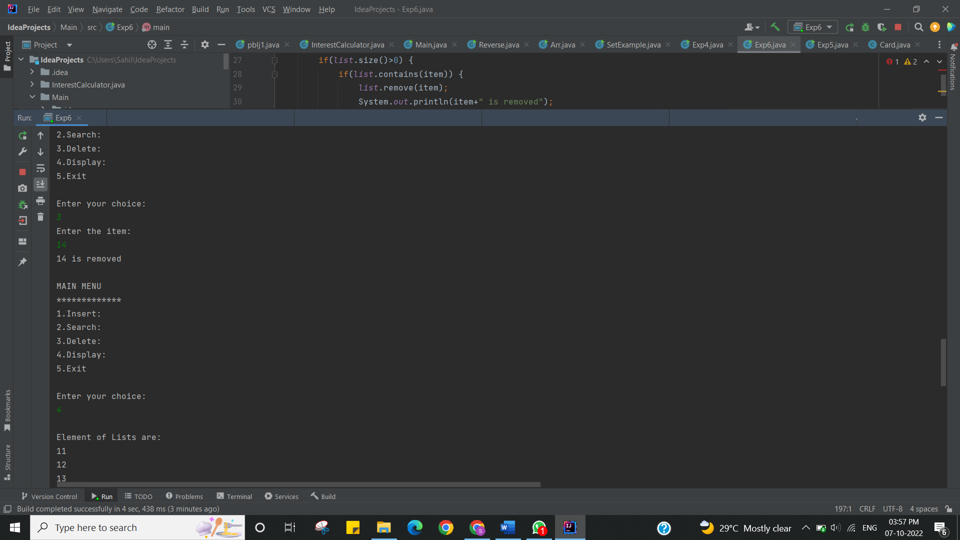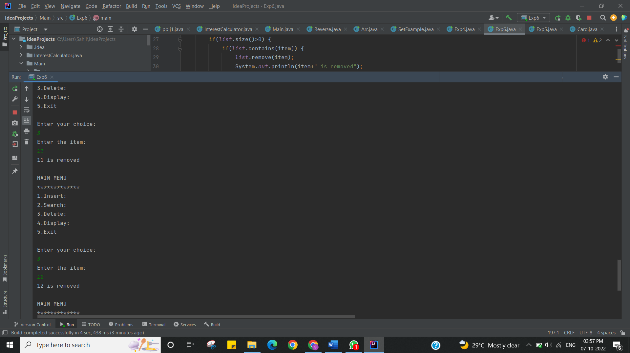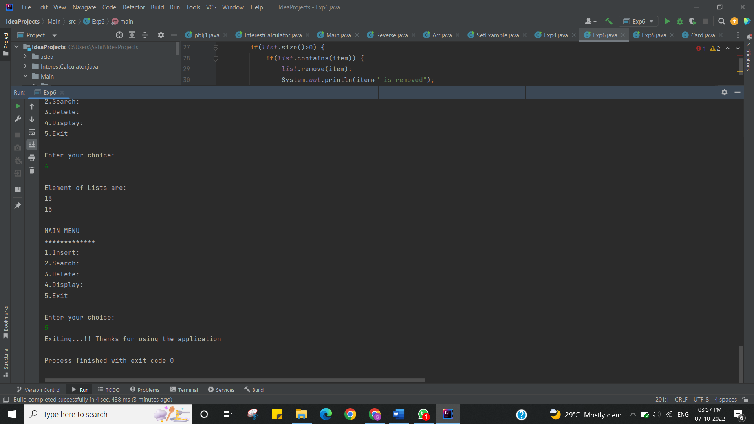

I have successfully done this program.

**Learning Outcomes (What I have learnt):**

* Learnt while loop.
* List manipulation concept understood.
* Created list and performed all operation of list.
* Learnt the concept of switch concept.
* Learnt concept of inbuilt function in list.

**Evaluation Grid (To be created as per the SOP and Assessment guidelines by the faculty):**

|  |  |  |  |
| --- | --- | --- | --- |
| Sr. No. | Parameters | Marks Obtained | Maximum Marks |
| 1. |  |  |  |
| 2. |  |  |  |
| 3. |  |  |  |